8th Grade Pre-Algebra Section 5.4 Quiz Review Homework
Use unit analysis to convert the following questions:
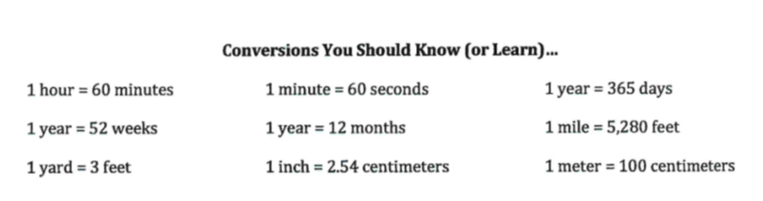
- 16 weeks to seconds

- 762 centimeters to feet

- 3 years to seconds

- 32 feet/second to meters/second

- 88 inches/second to miles/day

